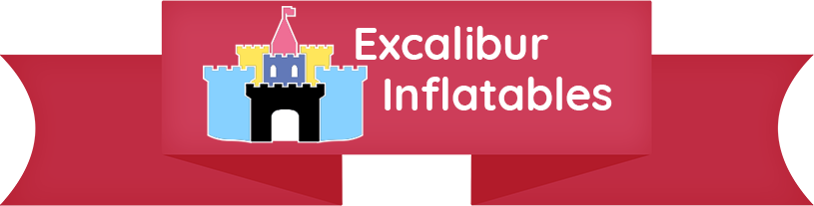

**Hire Agreement**

Name: Mr/Mrs/Miss

Address/Venue:

Castle(s):

Price: £

Times:

**Terms**

I/We the undersigned hereby accept that we, and anybody using this equipment under this hire agreement, use the equipment dated as above entirely at our own risk, on our own responsibility, and that the owner of this equipment accepts no liability for any damage, injury or loss to persons or property resulting from the use of this equipment on the basis that such is beyond the control of the owner.

I/We the undersigned have been given safety guidelines/terms and conditions of hire, and have read and understood them and will abide by them.

I/We the undersigned have examined the equipment with the operator and agree that it is in perfect working order. I therefore accept responsibility for any damage or loss to this equipment whilst hired to me under this hire agreement and I accept that I will be held liable for its consequent repair or replacement.

I/We will not move or attempt to move the inflatable from the position in which Excalibur Inflatables have secured it.

I/We will ensure the inflatable is as clean on collection as it was when delivered or will pay a cleaning charge (the cost of hire again).

Signed: Print Name:

Home Address (if different from above):